**CS-114 – Fundamental of Programing**

**Course Instructor: Dr Khwaja Fahad Iqbal**

**Lab Instructor: Muhammad Affan**

**LAB MANUAL #2**

**HOME TASK**

**ME 15 Section B**

**Student Name : Ahmad Aleem Akhtar**

**CMS ID: 458945**

**Date of submission : 12-10-2023.**

**TASK 1**

Code:

#include<iostream>

using namespace std;

int main ()

{

int m;

cout<<"Enter your marks : "<<endl;

cin>>m; //taking input from user and storing in m

//using else if loop to check in which range the marks fall and assigning grade

if(m<=100 && m>=90) //using Logical AND operator to check if the marks lie in the range

cout<<"Your grade is A";

else if(m<90 && m>=75)

cout<<"Your grade is B";

else if(m<75 && m>=60)

cout<<"Your grade is C";

else if(m<60 && m>=45)

cout<<"Your grade is D";

else

cout<<"Your grade is F";

// curly brackets are not needed since there is only one line of code after each condition.

return 0;

}

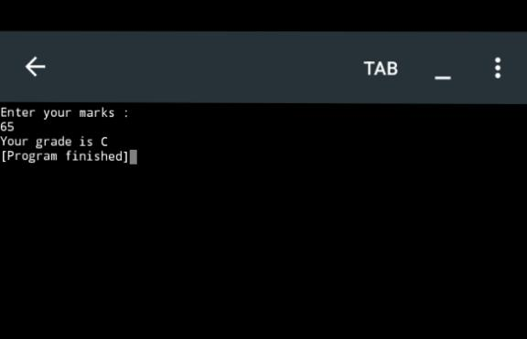Output screen:

**TASK 2**

Code:

#include<iostream>

using namespace std;

int main()

{

int a, r2, r5;

cout<<"enter a number";

cin>>a;

r2=a%2; //storing the remainder when a is divided by 2 in r2.

r5=a%5;//storing the remainder when a is divided by 5 in r5.

if(r2==0 && r5==0) //in order for the number to be even r2 must be zero and for it to be divisible by 5 r5 must be equal to zero.

cout<<"The number is even and is divisible by 5"; else if (r2==0)

cout<<"The number is even but not divisible by 5";

else if (r5==0)

cout<<"The number not even but is divisible by 5";

else

cout<<"The number is neither even nor divisible by 5";

return 0;

}

Output screen:

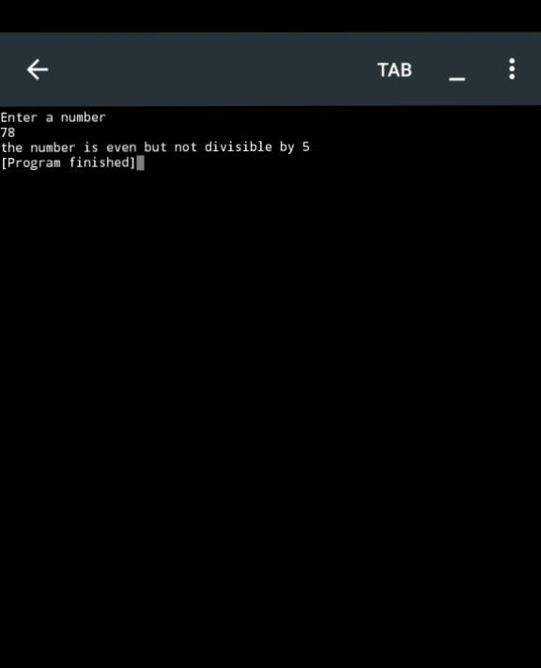

**TASK 3**

**Code:**

#include<iostream>

using namespace std;

int main()

{

//this program is designed to check if a given year is a leap year or not. a leap year occurs every 4 years. So we check by dividing by 4. But if the year is a multiple of 100 then it must also be divisible by 400 as a leap year comes at the start of a century every 400 years.

int y;

cout<<"Enter a year "<<endl;

cin>>y;

if(y%4==0) //checking if the year is divisible by 4

{

if(y%100==0)//if the year is divisible by 100 then it must also be divisible by 400 for it to be a leap year. we can check this by using another nested for loop inside of the nested for loop.

{

if(y%400==0)

cout<<y<<" is a leap year.";

else

cout<<y<<" is not a leap year.";

}

else//if the year is divisible by 4 and not divisible by 100 then it is a leap year.

cout<<y<<" is a leap year.";

}

else

cout<<y<<" is not a leap year";

return 0;

}

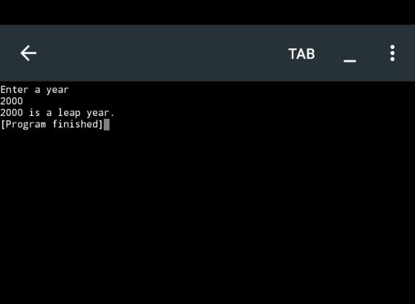Output screen:

**TASK 4**

Code:

#include<iostream>

using namespace std;

int main()

{

float gpa, att; //declaring two variables of float data type

cout<<"Enter your gpa and attendance %"<<endl; cin>>gpa>>att;

if(gpa>=3.5 && att>=80) //using Logical AND operator to check if both conditions are met

cout<<"you are eligible for scholarship";

else

cout<<"you are not eligible for scholarship";

return 0;

}

Output:

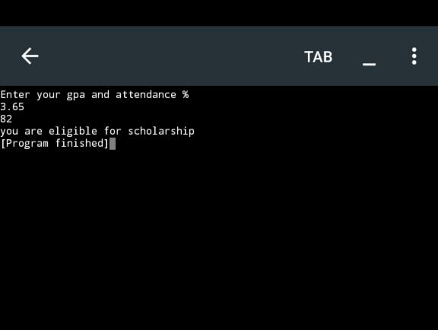

**TASK 5**

Code :

#include<iostream>

using namespace std;

int main()

{

char letter; //declaring a character variable

cout<<"enter any letter"<<endl;

cin>>letter; //takking a char from user and storing in variable

if(letter=='a' || letter=='e' || letter=='i' || letter=='o' || letter=='u') //condition to check if the char is a vowel

cout<<letter<<" is a vowel";

else //to be displayed if the char is not a vowel

cout<<letter<<" is a consonant";

return 0;

}

Output screen :

